Marriott International’s Cybersecurity Strategy Implementation

Christopher Phan, Shaquilla Chambers, and Zach Zerger

Strategic Cybersecurity Practicum CYBS 8396
Dr. Branden Williams
July 25, 2023

Table of Contents
Executive Summary 3
Security Metrics 4
Measurement 1: Number of Security Incidents 4
Figure 1 5
Measurement 2: Mean Time to Detect (MTTD) 5
Figure 2 6
Measurement 3: Rate of User for Phishing Simulation 7
Figure 3 7
Completion Rate of User for Security Awareness Training 8
Figure 4 9
Business Contingency Strategy 9
Figure 5 10
Figure 6 11
Incident Response 12
Security Staffing and Resource Strategy 16
SOC Analyst Job Posting 19
What Is The Role 19
Who We Are 20
Requirements 20
Responsibilities 21
Security Awareness and Education Plan 21
Elements of the Awareness and Education Program 22
Creators, Distributors, and Audience 22
Communication and Training Techniques 22
Key Topics Covered 23
Frequency of Communication and Training 24
Measurement of Impact 24
Security Newsletter Brochure 26
Cybersecurity Budget 27
Figure 7 27
Conclusion 28
Cybersecurity Strategy 28
References 30

Executive Summary
Before beginning this second part of our cybersecurity implementation strategy, we will revisit the significance of our first portion. Part one of our cybersecurity strategies discussed: (1) Marriott International’s base values such as our business and cybersecurity mission and core values, (2) how our security teams will be organized to support Marriott International and the reasoning behind the organization structure, and (3) the top four security challenges that are presented within Marriott International, which include data security challenges, insider threats, third-party vendor risks, and upkeep of regulatory bodies. The purpose of this first portion is to establish the goals of our plan to combat the events that have recently occurred against Marriott International, highlighting the threats, creating contingency procedures, and developing the proper infrastructure to prevent and mitigate these vulnerabilities. Also, it exemplifies the standards we want to expand upon for the future of our company, emphasizing security culture and improving everything that our core values detail.
What this second volume will do is focus on practical solutions to execute the conceptual foundation that was laid out in part one. These practical applications will include how we will measure our security efficiencies through a homegrown metric system, a business continuity program that will describe how Marriott International will operate even if critical systems are malfunctioning, incident response plans utilizing information from previous cyberattacks that happened in Marriott International’s past, a security staffing strategy detailing retention and overturn of key security personnel, including a job posting as a visual aide to gain employee talent, a cybersecurity awareness and training procedural guide with an accompanying newsletter, and lastly, a budgeting plan that will be required for the security operations here at Marriott International. These will be the main points of discussion for part two, which will be essential to the processing of our strategy as it shall present how Marriott International operates for future cybersecurity developments. Thus these elements describe will set forth the requirements for a successful cybersecurity program that can help support our vision statement of being the best travel company in the world.

Security Metrics
Due to the data breach in 2018, Marriott International has to make significant efforts to improve cyber posture and resilience. Apart from our cybersecurity strategy, we implemented robust security metrics that are crucial for evaluating and maintaining the security posture of Marriott International. These metrics provide valuable insights into the organization's security landscape, identifying vulnerabilities, assessing the effectiveness of security measures, and driving improvements in incident response and user awareness. UpGuard, a cyber resilience platform, stated, " The analysis of Key Performance Indicators (KPIs), Key Risk Indicators (KRIs), and security postures provides a snapshot of how your security team is functioning over time. This helps you better understand what is working, which information technology assets are most at risk, and which areas are worsening. This information aids in decision-making around budget, people, and technology investment" (Tunggal, 2023). By focusing on these key security metrics, Marriott International can effectively measure and analyze its security protocols, strengthen its defenses, and protect against evolving threats.

Measurement 1: Number of Security Incidents
The number of security incidents refers to the total count of security breaches, incidents, or vulnerabilities within the Marriott International infrastructure. Gathering this data offers a quantitative measure of the security posture of Marriott International. It helps identify trends, patterns, and potential areas of weakness in the security system. Figure 1 offers a visual representation of the number of security incidents, highlighting potential areas of weakness in the security system. This metric can be used to assess the effectiveness of security measures and identify areas for improvement.
The audience for this metric includes the security team, IT management, and senior executives at Marriott International. It provides crucial information for decision-making related to security investments and resource allocation. The collection and reporting of this metric is done on a real-time or near real-time basis. Security incidents are logged and recorded as soon as they are detected. Regular reports are also generated monthly or quarterly to summarize the incidents and trends. The responsibility for collecting, analyzing, and reporting the number of security incidents lies with the Marriott International SOC team. They are responsible for monitoring the security infrastructure, identifying incidents, conducting investigations, and generating reports.

Figure 1
Fictional Number of Security Incident Bar Graph
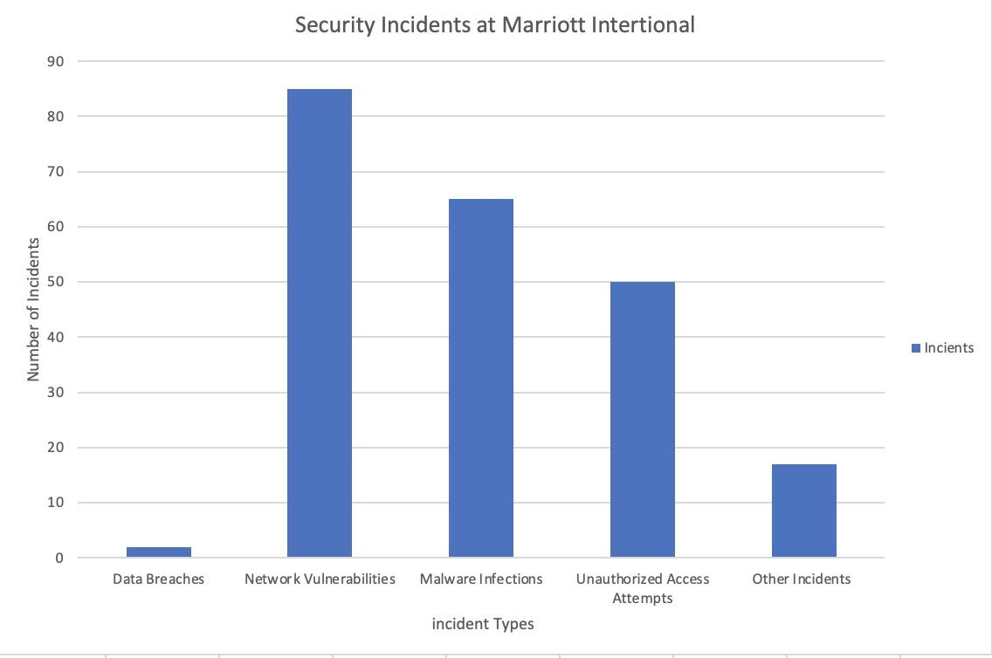

Measurement 2: Mean Time to Detect (MTTD)
Mean Time to Detect (MTTD) refers to the average time it takes to detect a security incident or breach within the Marriott International infrastructure, from the initial occurrence to the moment it's detected. Gathering the MTTD metric helps understand the efficiency of the security monitoring and detection systems. Furthermore, to facilitate a visual representation of the Mean Time to Detect (MTTD) metric, refer to (Figure 2). The image illustrates the timeline of incident detection, showcasing the average time it takes to detect security incidents within the Marriott International infrastructure.
The audience for this metric includes the security team, IT operations team, and senior management at Marriott International. It provides valuable information for assessing the efficacy of security processes and making informed decisions regarding incident response. "According to the SANS 2019 Incident Response survey, 52.6% of organizations had an MTTD of less than 24 hours, while 81.4% had an MTTD of 30 days or less. Once an incident is detected, 67% of organizations report an MTTR of less than 24 hours, with that number increasing to 95.8% when measuring an MTTR of less than 30 days: (MTTD and MTTR: Two metrics to improve your cybersecurity, 2020). The monitoring, tracking, and reporting of MTTD should be continual. Each incident's detection time should be recorded and measured. Monthly or quarterly reports can be produced on a regular basis to assess trends and identify areas that need improvement. Marriott International's security operations center (SOC) team gathers, examines, and reports the MTTD measure. They are in charge of keeping track of detection times, monitoring security systems, and looking into events.

Figure 2
Fictional Mean Time To Detect Bar Graph
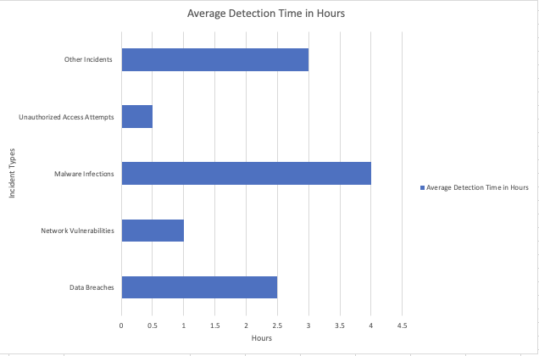

Measurement 3: Rate of User for Phishing Simulation
The number of users that interact with or fall for simulated phishing efforts, or the rate of user engagement in phishing simulations. The amount of user participation in phishing simulations is measured in order to evaluate the success of security awareness training programs and pinpoint any areas that may require more instruction and reinforcement. It gives information on how susceptible the company is to phishing attempts and aids in gauging the effectiveness of mitigation measures. The statistics will be used to assess Marriott staff members' general security awareness and evaluate the success of training programs. It may be used to spot trends, patterns, or departments that can benefit from further training or focused awareness initiatives. Additionally, it assists in measuring the results of security awareness campaigns and tracking improvement over time.
In addition, a visual representation (Figure 3) has been provided to paint a clearer understanding of the rate of user engagement in phishing simulations. The primary audience for this metric would be the information security team and management within Marriott. They are responsible for implementing security measures, developing training programs, and ensuring the organization's overall security posture. The metric may also be shared with executives and stakeholders to demonstrate the organization's commitment to security.

Figure 3
Fictional Pie Chart of User Engagement of a Monthly Phishing Simulation
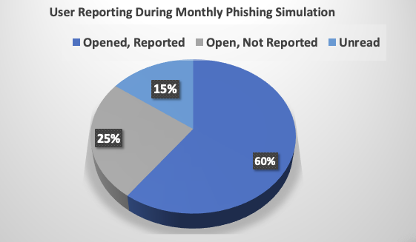

Completion Rate of User for Security Awareness Training
Marriott International tracks and collects the number of employees who have completed the required security awareness training. We manage and track the user awareness training completion rate helps in assessing the level of employee engagement and understanding of security best practices. It ensures employees receive the necessary education to protect against common security threats. The metrics will be used to evaluate the effectiveness of the security awareness training initiatives. This will help identify gaps in employee security awareness education, track improvements over time, and measure the overall security awareness culture within the organization. The individual that will read these metrics includes the security team, internal auditors, and senior management. It provides insights into the level of employee engagement in security awareness training and helps make decisions regarding training strategies.
Collecting and reporting the user awareness training completion rate can be done periodically, such as quarterly or annually. For example, the applications and development team members are required to complete role-based security training annually to adhere to OWASP see (Figure 4). The completion status of each employee should be recorded and updated as training programs are completed. The responsibility for collecting, analyzing, and reporting the user awareness training completion rate lies with the security training and awareness team, which falls under the Governance, Risk, and Compliance (GRC) department. They manage the training programs, track completion rates, and generate reports.

Figure 4
Fictional Pie Chart of Rate of Completion for Awareness Training
.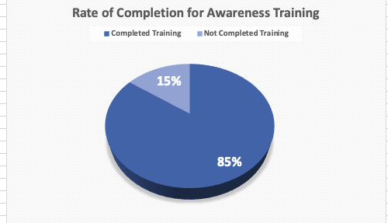

Business Contingency Strategy
As a global corporation, availability is critical for Marriott because it needs to process customer payments and reservation information around the clock. To keep critical data and systems available, contingency plans must be in place when an incident occurs. One of the keys to being prepared is the creation of a Contingency Planning and Management Team (CPMT) that will develop a contingency policy and analyze the overall risk-specific scenarios for the availability of critical systems. This team will consist of the CISO and project management team. The team will conduct Business Impact Analysis (BIA) and create groups to head up the Incident Response Plan (IRP), Disaster Recovery Plan (DRP), and Business Continuity Plan (BCP).
A BCP is an overarching plan that provides policies and procedures for keeping critical data and systems running after a disruption (Swanson et al., 2002). The plan includes business operations at its headquarters, regional offices, and thousands of hotel locations. The plan focuses on the critical systems that are vital to continuing to operate during a disruption. The scope of the BCP will not include non-critical systems and data and will not detail specifics on longer-term outages. More detailed plans will be outlined separately, such as the DRP and IRP. The BCP includes aspects of the business other than IT, but this plan will focus on the data and systems portion of the plan. Figure 5 shows the relationships between the different contingency plans.

Figure 5
Contingency Plan Relationships
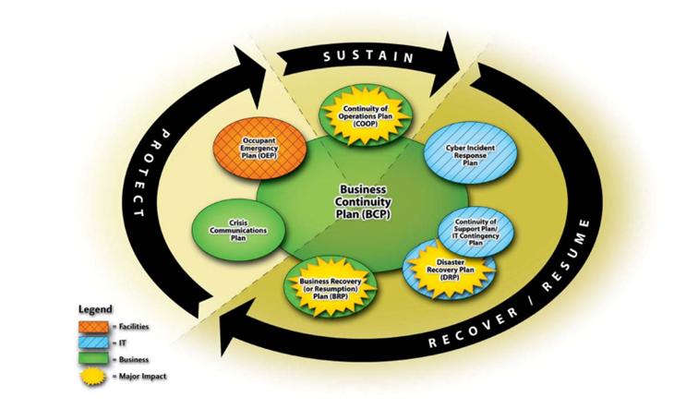
Note: From Swanson MA, Grance T, Hash J, Pope L, Thomas R, Wohl A. (2002) Contingency Planning Guide for Information Technology Systems. NIST Special Publication (SP) 800-34. https://www.fismacenter.com/sp800-34.pdf
Marriott's BCP will focus on flexibility and scalability across different regions. Marriott operates in 138 countries and territories, with thousands of endpoints from each region feeding data into the network. This data includes sensitive financial information, customer information, reservation transactional, and associate information that must be backed up securely and accessible during a disruption. The company's critical systems and applications must be available for payments and reservations during a disruption.
The company plans to adopt a cloud backup strategy that will give it the flexibility and scalability needed for such an extensive spread-out data infrastructure. Amazon Web Services (AWS) offers a Pilot Light recovery strategy and solution that can be used for short-term disruptions or longer-term disaster situations. The concept is based on having some critical Infrastructure-as-a-Service (IaaS) mirroring Marriott's current systems, applications, and backups at all times in the cloud. This option is scalable as one can rapidly duplicate instances in the cloud and add storage when necessary. The solution also reduces Recovery Time Objective (RTO), only taking minutes to recover from a disruption, minimizing downtime. The option is also more cost-effective than keeping warm or hot site backups because you are not paying for the entire replicated infrastructure. Pilot Light also offers the ability to duplicate storage across regions, adding another layer of resiliency to the company's contingency strategy (Disaster recovery options in the cloud, 2023). Figure 6 shows an example of AWS cloud backup architecture across regions.

Figure 6
AWS Backup Architecture
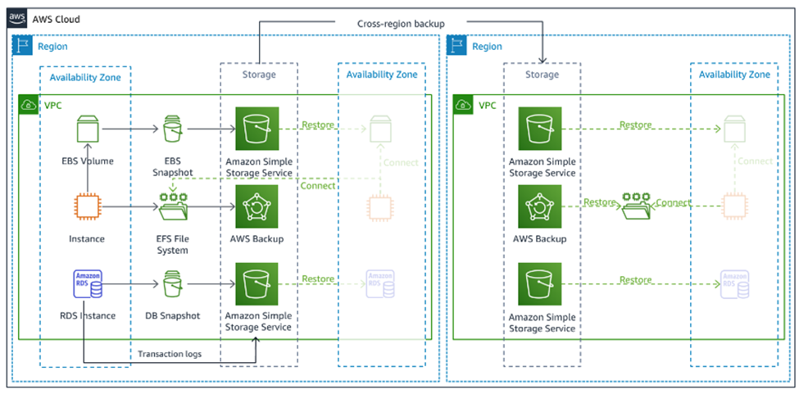Note: From Disaster recovery options in the cloud - Disaster Recovery of Workloads on AWS: Recovery in the Cloud. (2023). www.aws.amazon.com. https://docs.aws.amazon.com/whitepapers/latest/disaster-recovery-workloads-on-aws/disaster-recovery-options-in-the-cloud.html
AWS Pilot Light allows the company to replicate critical servers, applications, and databases in the cloud. The infrastructure in the cloud is continuously running, and the backup of data is done on a regular basis. The flexibility and scalability of the cloud allow the company to pay for what it needs when it needs it. Another benefit of the cloud infrastructure is that it allows for easy testing. Cloud replication can be monitored and checked weekly by members of the contingency management team. The BCP would be tested through structured walk-throughs on a semi-annual basis, and a full simulation would be run annually.
The BCP would be the responsibility of a business continuity manager who coordinates and oversees the plan's planning, implementation, and testing. The manager would have a team that focused on contingency planning and policies. The team would also comprise members of the more specialized contingency groups, such as the incident and disaster response managers. There would also be representatives from different regions and departments that are in charge of communicating the plan to their staff. The testing, monitoring, and readiness metrics would all be communicated to the CISO by the business continuity manager.

Incident Response
Marriott has been hit hard with data theft incidents over the past three years, with one incident accounting for the theft of millions of credit card and passport numbers. The company has yet to be hit with a ransomware attack even with these incidents. It is just a matter of time when 24 percent of breaches last year involved ransomware. Ransom attacks continue to evolve, and ransomware-as-a-service is becoming more mainstream and ubiquitous as it becomes easier for less sophisticated actors to pull off the attacks. Ransomware attackers are looking for financial gains and will target large companies as the payouts from attacks ranged from $1 and $2.25 million in 2022 (Data Breach Investigations Report, 2023).
To prepare for a future ransomware attack, Marriott needs to develop an Incident Response Plan (IRP). The development of an IRP falls under the protection function of the National Institute of Standards and Technology’s (NIST) Cybersecurity Framework (NIST Framework, 2018). To help protect the company, it needs to invest in deploying technology that detects, contains, and remediates the ransomware threat.
Marriott’s business model opens itself up to attacks because it has an extensive network of endpoints spread across the globe. Endpoint security is essential to detect and contain ransomware attacks before they penetrate the network. Having antivirus software on all endpoints is critical to start. Endpoint Detection and Response (EDR) systems are a great way to detect, detain and respond to attacks at the endpoint employee workstation level.
The next security feature Marriott should adopt is Intrusion Detection Systems (IDS) and Intrusion Detection Systems (IPS) to help detect and stop suspicious network traffic in real-time. This would add to a defense-in-depth network security strategy that would make it more difficult for the attackers to get to where they want to attack in the network. IDS/IPS can also be integrated with sophisticated firewalls to help identify unknown attacks. These systems would be strategically placed in the network to help defend and seal off specific network segments from potential attacks.
To coordinate all the security technology, the company must invest in good Security Information and Event Management (SIEM) systems. The SIEM acts as a hub that will collect the logs from all the network systems and devices and correlate them. It can be used to alert staff that an attack is happening, and then it can be used to coordinate the response to the attack.
Backup and recovery systems are essential when recovering from a ransomware attack. The BC plan discusses that availability is vital to Marriott’s business model. The company must conduct database shadowing to make multiple cloud backups in multiple regions. In case of an attack, the backups will provide the ability to continue operations at some level of availability.
The first step in creating the company’s IRP is establishing a Computer Security Incident Response Team (CSIRT). The CSIRT should be composed of a specialized team of incident responders that bring different expertise to the table. The team will have a designated incident response manager and a group of incident responders already working in the Security Operations Center (SOC). The team will be one centralized team within the company headquarters. The response manager will report to the CISO and the Chief Privacy Officer (CPO) in cases where sensitive data is compromised. These roles would then report to the Chief Information Officer (CIO) depending on the nature of the incident. The team should also consist of specialized digital forensics and threat intelligence personnel. The team should also have an alert roster for key IT personnel responsible for critical applications or IT systems. CSIRT will also work closely with the legal, public affairs, and business continuity planning teams. The IRP will also list contingencies to outsource digital forensic work to a third-party vendor to help secure evidence in case the company can prosecute any bad actors.
The team will need policies and procedures to follow for most known and unknown incident situations. The first task of the CSIRT team will be to identify what data and systems have been compromised once an incident is identified. It should be evident that a ransomware attack has occurred based on the ransom request. Policies and Standard Operating Procedures (SOPs) should be in place to direct the incident response manager on what he needs to do based on the extent and prioritization of the breach. Ransomware breaches will be the highest priority due to their high functional, informational, and recoverability impacts on the business (Cichonski et al., 2012). The best scenario with a ransomware attack is if they have only infiltrated a portion of the network, and the rest of the business can still function normally. Worst case, the network is taken down, and the bad actor has encrypted and extracted sensitive personal data.
The incident response plan would be tested semi-annually with a combination of tabletop and red exercises. Tabletop exercises would be used to work out any issues with alerting key personnel and ironing out communication strategies with other departments. The red team exercises test the effectiveness of the plan. The key to the testing is to conduct post-incident reviews and identify areas of improvement.
Once an incident is identified, Marriott should have an incident notification procedure. In the case of ransomware attacks, they are likely time sensitive and will need to be communicated to leadership immediately. Each breach will be discussed with the legal department, and any large ransomware breaches will be communicated to the Cybersecurity & Infrastructure Security Agency (CISA) and local and federal law enforcement. The company believes sharing intelligence on the ransomware groups is important so federal authorities can dismantle them. In past cases, federal authorities have been able to recover portions of the ransomware attack payments. In the 2021 Colonial pipeline attack, the US Department of Justice (DOJ) recovered 2.3 million in cryptocurrency that was paid by the company (DOJ, 2021). If the incident involves protected personal information, there are also reporting requirements, such as Article 33 of the General Data Protection Regulation (GDPR), which requires the company to report the incident to European Union authorities within 72 hours of becoming aware of the incident (GDPR, 2022).
One of the biggest dilemmas with a ransomware attack is whether to pay the ransom or not. Sophisticated ransomware groups encrypt company data, extract it from networks, and double extort the companies by threatening to leak their sensitive data. Each scenario will be unique, but the company must carefully weigh its options. Based on cash flows, the company stands to lose close to $5 million a day if the network is shut down and it cannot operate. If the sensitive data is extracted and released, it could significantly damage the company’s reputation, and regulators would increase fines on the company. These fines would be significant after past breaches showed the company could not adequately secure sensitive information. Backup cloud-based infrastructure is the best recovery option. In some scenarios, the company may pay a ransom based on the likelihood that the bad actor has extracted sensitive information from the network and the cost associated with lack of availability. If sensitive data has not been extracted in cleartext, the choice would be not to pay the ransom and use cloud backup. If cleartext sensitive data was extracted, the company would weigh the costs knowing that even if the ransom is paid, the bad actor may still release the sensitive data. If the ransom is paid, the company would work closely with authorities to pursue and prosecute those responsible and try to recover the money.
The final steps of the IRP will be recovery and then learning from the incident. Members of the CSIRT team will conduct recovery of operations and ensure all systems are operational, any malware has been removed, and the data has been recovered. The team will also ensure logs are kept from the incident for future forensic analysis and use as evidence. The final step will be to evaluate and learn lessons from the incident and response. These lessons must be communicated to stakeholders and management so the company can be more prepared.

Security Staffing and Resource Strategy
At Marriott International, we want the best and brightest in the field to help support our mission, uplifting our core values of putting people first by giving them opportunities for security and the vertical mobility they require. How we will acquire new talent into our infrastructure through a multitude of vectors, including online job boards such as LinkedIn and Indeed, direct references from our security teams, career fairs at universities to get first picks on rising professionals, and tailored ads and a user-friendly career page part of Marriott International’s website. These will be the main vectors in acquiring new hires, however, we will be prioritizing references given by our security team, as with proper due diligence from the security team, could be a greater asset in the future. Although, these references will have to be vetted as well by security managers directly and will have to go through the proper procedures in the hiring process. What we are looking for in these new hires are skills like: (1) eagerness to learn new skills, especially in the field of cybersecurity where technology evolves at a highly rapid rate, (2) advanced problem-solving rationale, as unique issues need resolution on possibly a daily basis and understand future trends, (3) able to communicate their knowledge that can understand by all, as these hires must be capable of effectively convey their ideas, (4) attention to detail is highly prized as it is vital to be meticulous, (5) able to work both independently and synergize with their perspective teams, and (6) understanding of cybersecurity core values, their field’s application principles, and common methodologies. These 6 skills we believe are essential to all our security staff and want to continue to improve upon these skills.
The interviewing process for Marriott International will be four rounds of interviews for each possible new hire. The first round of interviews will be the human resources department check on the main principles of the candidate, and whether they match with the culture we have here at Marriott International. The second round of interviews will be an interview with the candidate and their prospective security manager, delving into their knowledge and main skills, and looking into how they can improve their team and Marriott International as a whole. Also, this interview establishes the expectations of the candidate in their job role, and what is needed for them for their applied position. The third round of interviews will be a technical interview to test their technical skills and their problem-solving reasoning, seeing how they think and the rationale behind their resolution for each issue, as well as the pace they can solve each problem. Lastly, the fourth round of interviews will be with upper management, this will see the main aspirations of the candidate and their overall role in the future of the company, although this will be more of an introductory interview as the candidate chooses to transition into working for Marriott International. The onboarding process for the candidate is a two-week training period, during which the candidate gets accustomed to Marriott International. The first week will be them acclimating to their team, setting up their accesses, introducing them to their team, and how they will be working with their team. Their second week will consist of a guided training session on their position, where the team will oversee the candidate and their progress. Once the third week has passed for the candidate, the manager will touch base with them to see how they are doing and if they need anything to efficiently do their role. What training will consist of during this onboarding process is showing the candidate how they will do their role by those who are in the same role, teaching how they will use the applications, and what they can do to support the team. As mentioned, during the second week, the candidate will be doing their position with oversight from the team, approving their actions before implementation, as well, a sandbox will be given to the appropriate candidates so they can test their skills without any effect on our operations.
How we will attract and maintain security staff and top talent through a variety of benefits they receive for working for Marriott International. These benefits will include a highly competitive compensation rate, free health insurance including dental and vision, life insurance policy, stock options, paid parental leave either it being paternal or maternal, the ability to work remotely, an annual increase in compensation rate and yearly bonuses, 401K matching, stipends for remote work, wifi, and phone, and unlimited PTO (however it will have to be approved by managers, usage of this will be noted and will have to be on-call in case of emergencies). Also, Marriott International can help pay for employee’s education, like if they are considering pursuing higher education like their master's in an adjacent field, paying for certifications such as CISSP and CompTIA Security+, sponsoring employees to go to conferences like Black Hat or RSA conferences so employees can meet like-minded professionals and improve their skills, and lastly Marriott International will give access to Pluralsight to employees so they can improve their security skills, either it being basic cybersecurity values or learning for certification of theirs. These benefits will help Marriott International retain staff for the future to come, as we will greatly take care of our employees as well as improve our employees' skills for the future.
Lastly, how we will be handling the leaving of a security employee from the company. We will be asking for, however not required, a month's advance notice, so we can prepare for this security employee's departure. There will be an exit interview asking how we can improve Marriott International and our security team to be stronger for our future, as well as what we can do to better retain our employees. We will begin posting on our job boards and advertising the new opening in the role, however, we will ask the leaving employee if they have any preferred replacement for their role, though they will have to go through the same process as new hires with the proper checks. We will also begin asking our security team if they have any preferred replacements to fill the gap. If possible, we would like this replacement to come in before the employee leaves, so this employee can teach the new replacement coming in before they have left the company. With this, the employee can directly teach the replacement their role and how to do their role, direct expectations they have for the replacement, and have a direct comparison in what they need to do. However, we do know that this month's notice will not always be possible, but it will be the preferred outcome. As expected, the employee will be needing to return all the company property, such as their machines and company phone, and there will be no PTO payout as there is no accrued PTO. This is how Marriott International will handle the departure of a security employee.

SOC Analyst Job Posting

What Is The Role
The Security Operations Center (SOC) Analyst, here at Marriott International, is our first line of defense, in the protection and detection of all suspicious and malicious behavior. Marriott International has more than 8,500 properties and millions of clients that need the greatest attention to detail and requires people who are willing to go above and beyond in defending our brand. SOC Analysts are highly valued here as they are the ones who will respond to any security events in real-time and protect the firm.

Who We Are
Here at Marriott International, we are a firm within the hospitality industry, committed to putting people first by being the number one travel company in the world, serving our employees and customers' needs to be at their very best. We want to excel in innovation in the field of hospitality and enhance customer satisfaction to the greatest of our ability, and have uncompromising integrity and surpass the standards of both ethical and legal degrees. That is who we are and who we are proud to be.

Requirements
What we are looking for in this SOC Analyst is:
- Bachelor’s degree in Computer Science, Information Technology, Cybersecurity, or a related field.
- Possible Master’s degree in the fields mentioned earlier.
- Recommended to have certifications in Security+, Network+, Certified Ethical Hacker, and other certifications that may make you stand out.
- Minimum 3 years of experience in working a position that is in a SOC role or adjacent cybersecurity transferable role.
- Familiarity or understanding of Security Information and Event Management systems, intrusion detection systems, configuration of firewalls and network logging applications, and analysis of those logs. As well, as an understanding of computer concepts such as network protocols, VPNs, and endpoint security.
- Experience with incident response and investigation of those events, which will include how to handle and solve those incidents, and digital forensics, which will be finding how those incidents occurred and how to mitigate the risks for future incidents.
- Experience with compliance with the Payment Card Industry Data Security Standards and General Data Protection Regulations, as these are the principal two regulations that Marriott International will be concerned with.

Responsibilities
The responsibilities that the SOC Analyst will have are:
- Our SOC team will be a global 24/7 operation, consisting of a completely in-house team.
- This team will have to be available for on-call emergencies at all times.
- Responsible for immediate real-time response to all alerts and reduction of risks and threats.
- Be able to provide an effective analysis of security events and vulnerabilities on retrieved data pinpointed from a myriad of endpoints and security systems that span globally.
- Efficiently communicate on any security events to both internal and external teams as necessary, and utilize problem-solving skills that can proficiently solve the issue presented by security events.
- Provide in-depth incident reports on security incidents and document information that may be useful for the foreseeable future.
- Lastly, able to work effectively in a team and create viable solutions in tandem with our security engineers and network teams for security projects that can improve security posture within Marriott International.

Security Awareness and Education Plan
Cybersecurity is a multi-disciplinary team effort, and it is an entire ecosystem that protects data confidentiality, integrity, and availability and aims to protect our democratic values and human rights. By implementing this security awareness blueprint, Marriott International can enhance employees' understanding of their roles and responsibilities regarding cybersecurity, fostering a culture of security awareness and reducing the organization's overall risk of cyber threats. Regular assessment and evaluation of the program's impact will help identify areas for improvement and ensure ongoing effectiveness.

Elements of the Awareness and Education Program
Marriott Intentional invested in a Learning Management Systems (LMS) tool that constantly develops a series of interactive training modules covering various cybersecurity topics. These modules are easily accessible to all employees through the dedicated online platform. We create concise and easily understandable documents outlining the organization's cybersecurity policies and procedures for awareness and education. In collaboration with the GRC team, the SOC team has established a system for the timely dissemination of security alerts and updates to keep employees informed about emerging threats, vulnerabilities, and best practices. We have a Report Phishing button implemented into the Microsoft Outlook toolbar to allow employees to report any suspicious activities or potential security incidents they encounter. The GRC team conducts regular simulated phishing campaigns to assess employees' attack susceptibility. They provide targeted training and address areas of vulnerability. As an initiative to keep employees engaged, we create an employee recognition program to reward individuals or teams who demonstrate exemplary security practices or contribute to the overall improvement of cybersecurity within the organization.

Creators, Distributors, and Audience
The training modules and materials are developed by a team of cybersecurity professionals in the LMS tool company in collaboration with subject matter experts from within Marriott International. The training materials are distributed through an online learning platform accessible to all employees, while newsletters and posters are distributed via email and displayed in common areas. The program targets all employees across various departments and levels within Marriott International, emphasizing that cybersecurity is everyone's responsibility.

Communication and Training Techniques
We help develop interactive e-learning modules with engaging multimedia elements, such as videos, quizzes, and interactive scenarios, to deliver comprehensive cybersecurity training. Also, we organize periodic workshops to provide face-to-face training, address specific concerns, and answer employee questions. During security awareness month, we conduct webinars on relevant cybersecurity topics, inviting guest speakers and experts to share their knowledge and insights with employees. We publish regular internal newsletters containing security tips, updates, success stories, and reminders of important security practices. “One of the most distressing language problems is that professionals do not agree amongst themselves on terminology and definitions. For non-expert audiences, cybersecurity is a complex and mysterious field that needs clarification. To meet that purpose, various definitions and taxonomies of technical cybersecurity jargon are used by different organizations" (Deursen,2022). In addition, we create visually appealing posters and infographics highlighting key security messages and place them in prominent areas within office spaces and digital communication channels.

Key Topics Covered
Our IT Security and GRC use tools to keep them informed about the latest scams and attacks, and we have tailored topics and repeated theme training. Some of the topics and themes we cover:
- Password Security to educate employees on creating strong passwords, using password managers, and implementing multi-factor authentication.
- Phishing and Social Engineering Awareness teaches employees how to identify phishing emails, suspicious links, and social engineering tactics.
- Data Protection to help educate the importance of safeguarding sensitive information, secure data handling practices, and compliance with data protection regulations.
- Mobile Device Security to educate employees on securing their mobile devices, including using strong passwords, encryption, and avoiding unsecured Wi-Fi networks.
- Safe Internet Browsing to promote safe browsing habits, including recognizing, and avoiding malicious websites, downloading software from trusted sources, and regularly updating web browsers.
- Ransomware helps educate employees about the risks of ransomware attacks and how to prevent them. It covers topics such as recognizing ransomware threats, avoiding suspicious email attachments or downloads, regularly updating software and operating systems, and maintaining backups of critical data to mitigate the impact of a ransomware attack.
- VPN to educate the importance of using VPNs for secure remote access to company resources and how it protects sensitive data from unauthorized access and ensures secure communication when accessing the company's network from outside the office.

Frequency of Communication and Training
All personnel are expected to complete initial training and extensive cybersecurity education before accessing our systems. Ongoing training refers to refresher training courses held quarterly or yearly to reinforce essential security concepts and handle new risks and trends. Continuous awareness is supplied by routinely communicating security messages to workers via newsletters, posters, and digital platforms to keep cybersecurity at the forefront of their minds.

Measurement of Impact
The IT team conducts pre-and post-training assessments to measure employees' knowledge and understanding of cybersecurity concepts, identify improvement areas, and track progress. We also monitor and analyze the results of simulated phishing campaigns to measure training effectiveness and identify areas for further improvement. And track the number and types of security incidents reported by employees to assess the effectiveness of the reporting mechanism and identify potential areas of concern. Also, we collect employee feedback through surveys or feedback sessions to gauge their perception of the training program, identify areas for improvement, and gather suggestions for future topics. We understand people learn differently and contain information from different standpoints, so we tailor information in different formats. We discovered that because different people learn in different ways, accelerated learning also encourages the adoption of various strategies to engage participants in training. These include:
- “Somatic or doing; for example, a workshop in which you have participants design their own phishing campaign (invoking the theory that you have to think like an attacker to defend against an attacker);
- Auditory or talking and hearing; for example, the modified Feynman technique I outline above fits nicely into this category;
- Visual or observing; a hacking demonstration is great for accessing this learning style;
- Intellectual or problem-solving; for example, with a table-top exercise that walks participants through a breach scenario and asks them to respond to the breach, overcome obstacles, and strategies solutions” (Barker et al., 2021).
We gauge the program's effectiveness in fostering a culture of security awareness and proactive behavior by tracking the number of workers acknowledged for their contributions to cybersecurity.

Security Newsletter Brochure
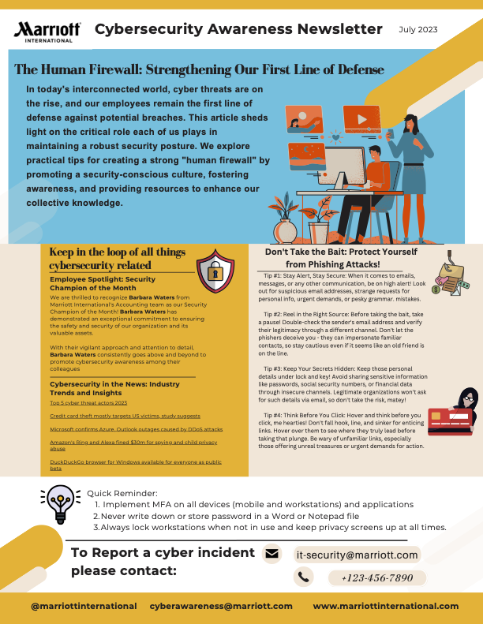

Cybersecurity Budget
Marriott's cybersecurity budget aligns with industry averages, with almost .3 percent of annual revenue being allocated for cybersecurity (Deloitte Center for Financial Services, 2020). The budget is currently $62.35 million and continues to increase as the company invests in its cybersecurity infrastructure and data protection. A key focus of the proposed budget is to invest heavily in hardware and software network infrastructure. Endpoint security, identity management solutions, and application security will be large expenditures in the upcoming budget as the company moves swiftly to protect its systems and data. See Figure 3 for a breakdown of the current budget.

Figure 7
Marriott’s Cybersecurity Budget
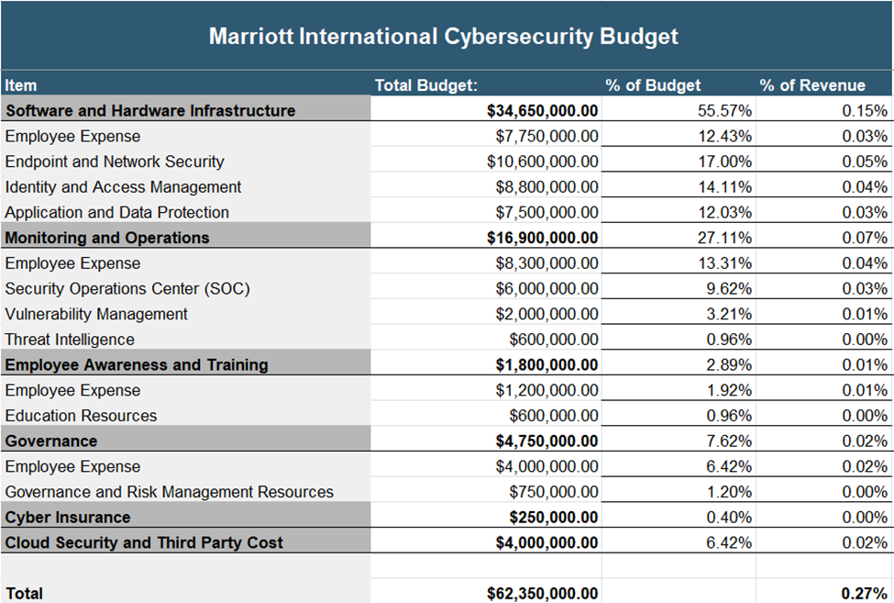
Note: Style template from: Wess, S. (2023). How to make a cybersecurity budget. Clutch.co. https://clutch.co/cybersecurity/resources/cybersecurity-budget

Conclusion
The past few years of security incidents have shown that the company should do what it takes to prepare for the next cybersecurity incident. To earn the stakeholders' trust, the company must provide confidentiality, integrity, and availability to its data and systems over the long term. This cybersecurity strategy outlines the company's way forward, including security metrics, contingency and incident planning, staffing, security awareness, and budget. Once the company adopts these strategies, it will be better equipped to handle new cybersecurity threats and will have instilled a security culture that prevents attacks through controls and training. Investing in cybersecurity will pay off dividends by securing the bottom line and brand reputation.

Cybersecurity Strategy
As Marriott International's Chief Information Security Officer, I emphasize that a multi-faceted approach to cybersecurity is crucial to tackling the diverse threats arising from an evolving landscape, human error, and increased system interconnectivity. To reinforce our cybersecurity strategy, the following areas need to focus on prioritizing cybersecurity, investing in employee training, establishing security metrics, optimizing resource strategy, and fostering a culture of security, we can strengthen our defenses against cyber threats. Regular monitoring, collaboration, and an effective business continuity plan are pivotal for maintaining a resilient cybersecurity posture amidst the evolving threat landscape.
It is essential for leadership to prioritize cybersecurity as the highest priority by implementing robust security measures and allocating sufficient funding and resources. This support includes bringing on qualified staff, making investments in cutting-edge equipment, and securing a sufficient budget for future requirements. Our first line of defense should be well-educated employees who are aware of emerging threats. Investing in cybersecurity awareness training can assist staff in recognizing threats and taking appropriate action, promoting a security-conscious culture.
Cyber incidents can be minimized by implementing an effective incident response plan that includes regular practice exercises. By defining metrics, we can assess the success of our cybersecurity initiatives. These benchmarks may include user compliance with security policies, incident response times, and the total number of vulnerabilities discovered. A comprehensive business continuity strategy also ensures that we can continue critical operations in the event of a catastrophe and quickly resume normal business activities.

References
Barker, J., Davis, A., Hallas, B., & Mahon, C. M. (2021). Cybersecurity abcs delivering awareness, behaviours and culture change. BCS, The Chartered Institute for IT.
Cichonski PR, Millar T, Grance T, Scarfone KA (2012) Computer Security Incident Handling Guide. (National Institute of Standards and Technology, Gaithersburg, MD), NIST Special Publication (SP) 800-61, Rev. 2. https://doi.org/10.6028/NIST.SP.800-61r2
Cybersecurity certification: CISSP - certified Information Systems Security professional. (ISC)2. (n.d.). https://www.isc2.org/Certifications/CISSP
Deursen, V. N. (2022). In Visual Communication for Cybersecurity: Beyond Awareness to advocacy (p. 20). essay, River Publishers.
Data Breach Investigations Report (DBIR). (2023). Verizon Enterprise Solutions. https://www.verizon.com/business/resources/T4dc/reports/2023-data-breach-investigations-report-dbir.pdf
Deloitte Center for Financial Services. (2020). Reshaping the Cybersecurity Landscape. www.deloitte.com. https://www2.deloitte.com/content/dam/insights/us/articles/6507_Cybersecurity-FS-ISAC/DI_2020-FS-ISAC-Cybersecurity.pdf
Department of Justice Seizes $2.3 Million in Cryptocurrency Paid to the Ransomware Extortionists Darkside. (2021, June 8). https://www.justice.gov/opa/pr/department-justice-seizes-23-million-cryptocurrency-paid-ransomware-extortionists-darkside
Disaster recovery options in the cloud - Disaster Recovery of Workloads on AWS: Recovery in the Cloud. (2023). www.aws.amazon.com. https://docs.aws.amazon.com/whitepapers/latest/disaster-recovery-workloads-on-aws/disaster-recovery-options-in-the-cloud.html
General Data Protection Regulation (GDPR) – Official Legal Text. (2022, September 27). General Data Protection Regulation (GDPR). https://gdpr-info.eu/
Joint Task Force (2020) Security and Privacy Controls for Information Systems and Organizations. (National Institute of Standards and Technology, Gaithersburg, MD), NIST Special Publication (SP) 800-53r5. https://doi.org/10.6028/NIST.SP.800-53r5
Marriott International: 2022 Annual Report. (2023). https://marriott.gcs-web.com/static-files/b82978a6-9d28-4e38-9855-fc4ae2cebe11
MTTD and MTTR: Two metrics to improve your cybersecurity. Threatpost English Global threatpostcom. (2020, September 28). https://threatpost.com/mttd-and-mttr-two-metrics-to-improve-your-cybersecurity/152149/
National Institute of Standards and Technology (2018) Framework for Improving Critical Infrastructure Cybersecurity, Version 1.1. (National Institute of Standards and Technology, Gaithersburg, MD). https://doi.org/10.6028/NIST.CSWP.04162018
Online courses, learning paths, and certifications. Pluralsight. (n.d.). https://www.pluralsight.com/
Security+ (plus) certification: CompTIA IT Certifications. CompTIA. (n.d.). https://www.comptia.org/certifications/security
State of the phish: At a glance - proofpoint. (n.d.). (2023).https://www.proofpoint.com/sites/default/files/infographics/pfpt-us-sotp-infographic.pdf
Swanson MA, Grance T, Hash J, Pope L, Thomas R, Wohl A. (2002) Contingency Planning Guide for Information Technology Systems. (National Institute of Standards and Technology, Gaithersburg, MD), NIST Special Publication (SP) 800-34. https://www.fismacenter.com/sp800-34.pdf
Tunggal, A. T. (2023, April 6). The most important security metrics to maintain compliance: Upguard. UpGuard. https://www.upguard.com/blog/security-metrics
Wess, S. (2023). How to make a cybersecurity budget. Clutch.co. https://clutch.co/cybersecurity/resources/cybersecurity-budget

